RSync:

<https://www.tecmint.com/rsync-local-remote-file-synchronization-commands/>

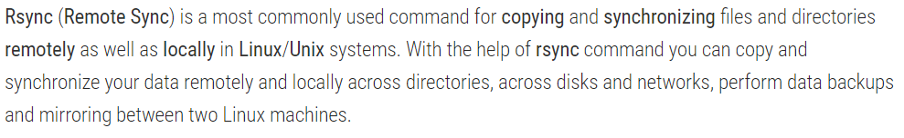

Advantages:

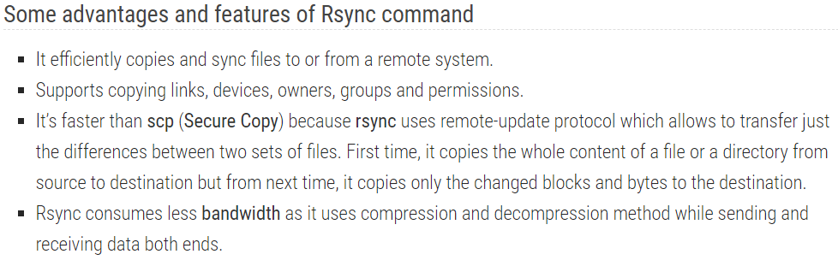

Installation:

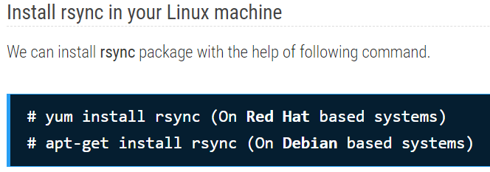

Basic info:

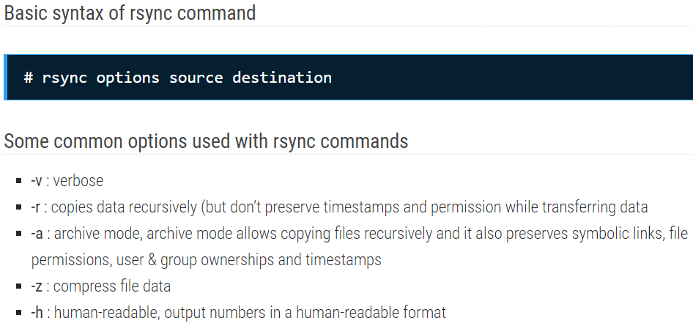

-z compresses the data while transferring

-h will give the human readable output with verbose. The size details will be in human readable format

Examples:

To copy a file:

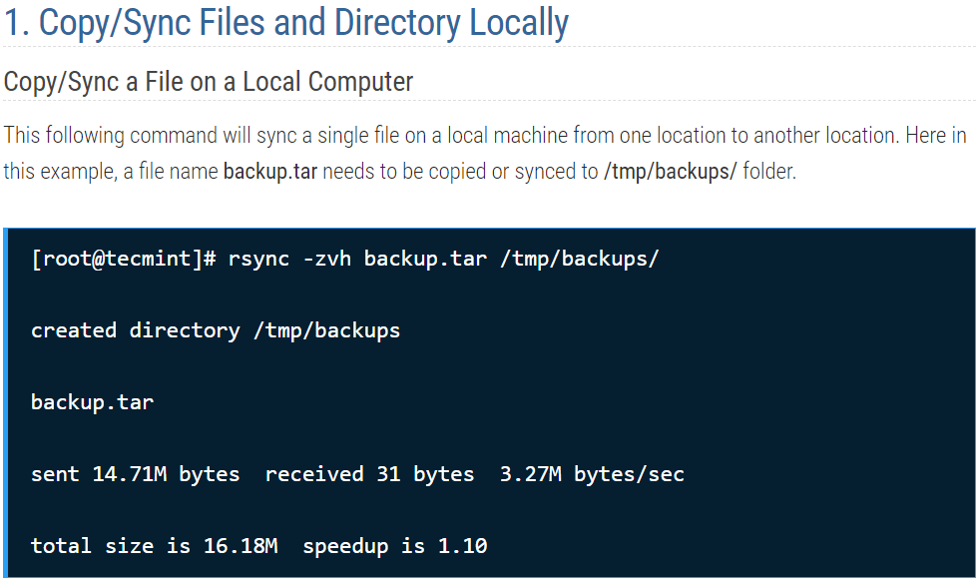

As above, the size details shown as human readable. Below is the output without passing -h in the command

Also, as per the above, if destination directory is not available, it will be created automatically

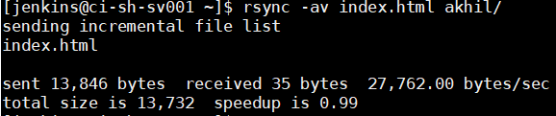

To copy a directory:

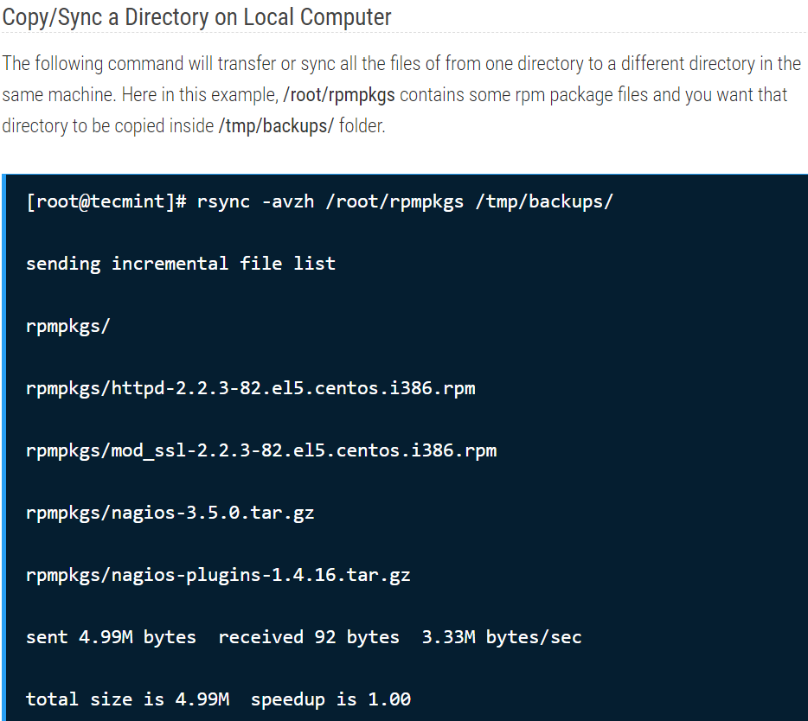

Directory from local to remote:

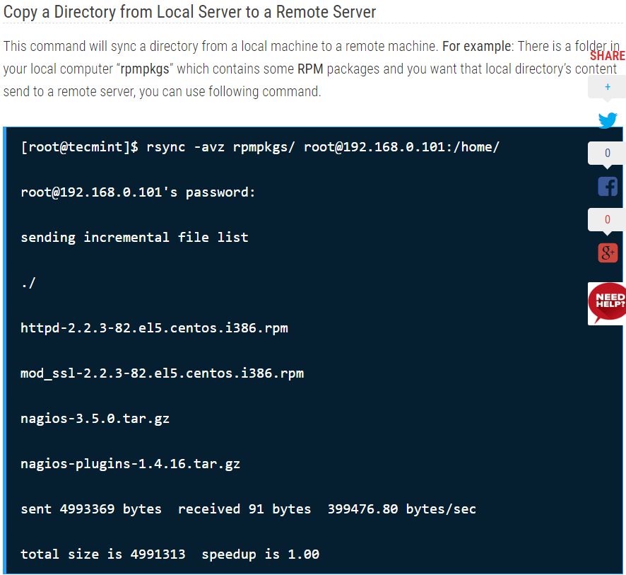

Copy remote directory to local:

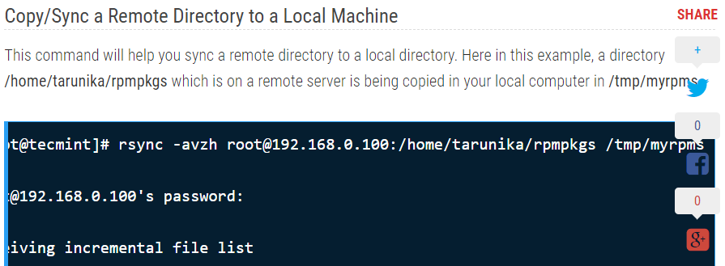

Rsync over SSH:

